

LAB EXPERIMENTS
ECA1011 Microprocessors and Microcontrollers

Submitted To:
Dr. EDWIN DHAS DHASON
Submitted By:
Name: DENISHASHREE R
Reg No: 192524124
Department: B.Tech AI & D

INDEX

S.No | Date | Title of Experiment | Page No
1. | 15/10/26 | EX 1: 8-bit and 16 bit Arithmetic Operations
2. | 17/10/26 | EX 2: Logical, Bit-manipulation And Shift  Operations
3. | 05/11/2026 | EX 3: Multi-Byte Data and Array Operations Using 8086 Indirect Addressing
4.
5.
6.
7.
8.
9.
10.

DATE: 15/10/2026

EXPERIMENT 01: ANALYSIS, DEVELOPMENT AND VERIFICATION OF 8-BIT AND 16-BIT ARITHMETIC OPERATIONS USING ASSEMBLY LANGUAGE PROGRAM

Objective:
- To analyze, develop & verify 8-bit Addition and Subtraction
- To analyze, develop & verify 16-bit Addition and Subtraction
- To analyze, develop & verify 8-bit Multiplication and Division
- To analyze, develop & verify 16-bit Multiplication and Division

Components Required:
8085 Simulator or 8085 Intel Microprocessor

Procedure:
- Switch ON the 8085-microprocessor kit or open the 8085 simulator.
- Enter the program opcodes into the specified starting memory address using the memory examine/substitute command.
- Store the required input data in the specified memory locations, if provided.
- Execute the program from the given starting address using the GO/EXEC command.
- Examine the memory locations assigned for the results.
- Record the output values and verify them with the expected arithmetic results.
- Repeat the procedure for all four programs and record the observations.

  - Analysis of 8-bit Addition and Subtraction :

PROGRAM [Addition]
MVI C 00h LDA 4200h MOV B A LDA 4201h ADD B
JNC SKIP INR C
SKIP : STA 4202h MOV A C
STA 4203h HLT

OUTPUT
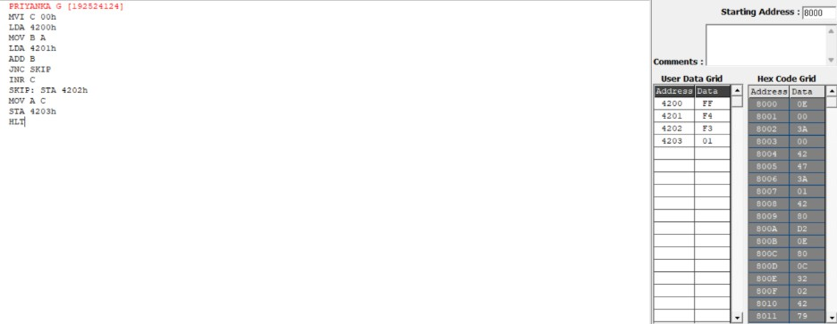

Memory | Data
4200 | FF
4201 | F4
4202 | F3
4203 | 01

PROGRAM [Subtraction]
MVI C 00h LDA 4201h MOV B A LDA 4200h SUB B
JNC SKIP CMA
INR A
INR C
SKIP : STA 4202h MOV A C
STA 4203h HLT

OUTPUT

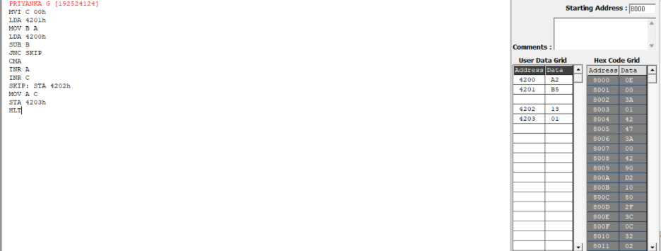

Memory | Data
4200 | A2
4201 | B5
4202 | 13
4203 | 01

  - Analysis of 16-bit Addition and Subtraction:

PROGRAM [Addition]
LHLD 4510 XCHG LHLD 4512 DAD D SHLD 4514
MVI A 00 JNC SKIP MVI A 01
SKIP: STA 4516 HLT

OUTPUT
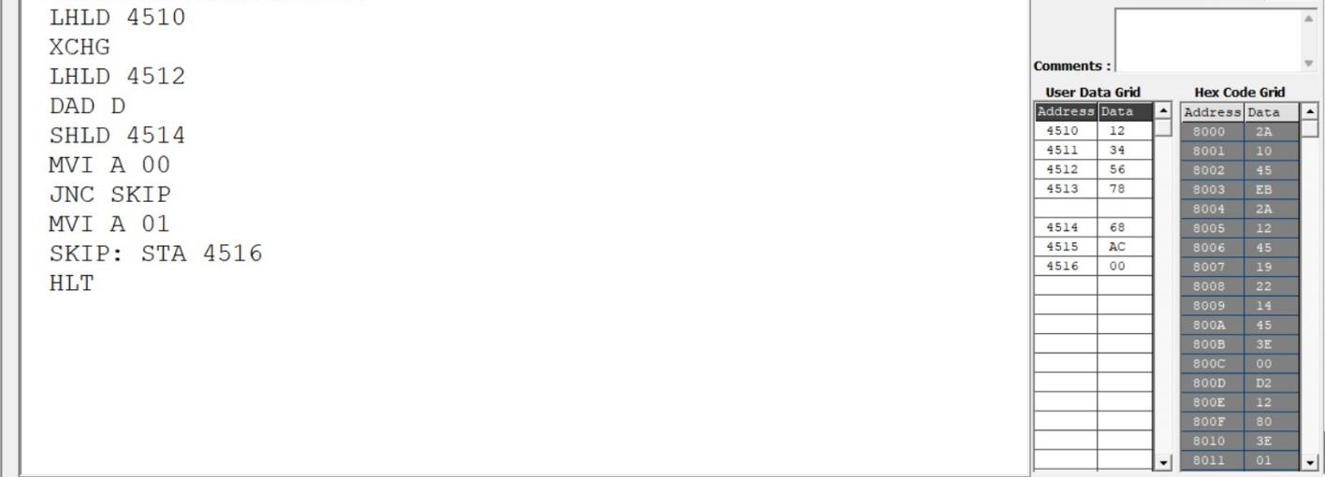

Memory | Data
4210 | 12
4211 | 34
4212 | 56
4213 | 78
4216 | 68
4217 | AC
4218 (carry) | 00

PROGRAM [Subtraction]
LDA 4510 MOV C A LDA 4511 MOV B A LDA 4512 SUB C STA 4516
LDA 4513 SBB B STA 4517
MVI A 00H JNC SKIP MVI A 01
SKIP: STA 4518 HLT

OUTPUT
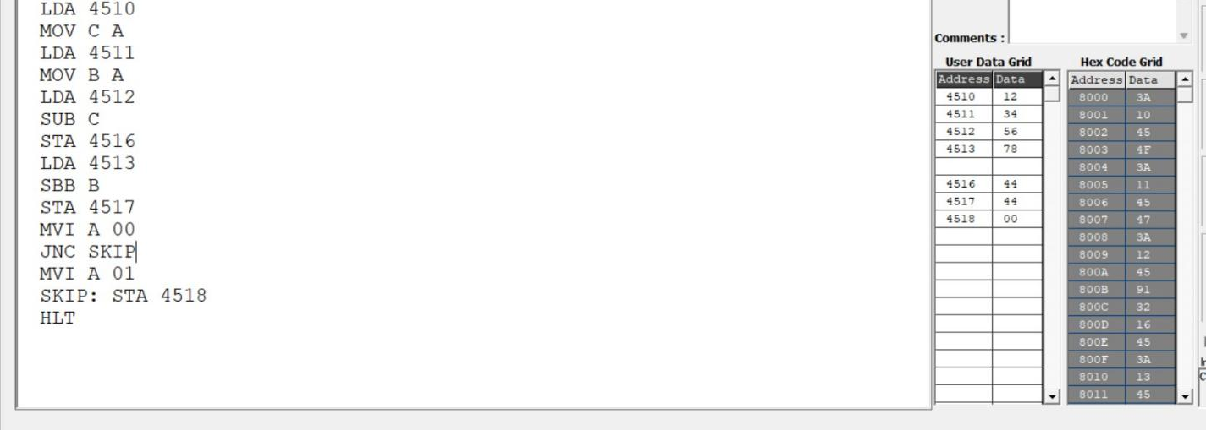

Memory | Data
4210 | 12
4211 | 34
4212 | 56
4213 | 78
4216 | 44
4217 | 44
4218 (carry) | 00

  - Analysis of 8-bit Multiplication and Division:

PROGRAM [Multiplication]
LXI H 0000H LDA 4201h MOV E A LDA 4202 MOV C A
REPEAT : DAD D DCR C
JNZ REPEAT SHLD 4203 HLT

OUTPUT
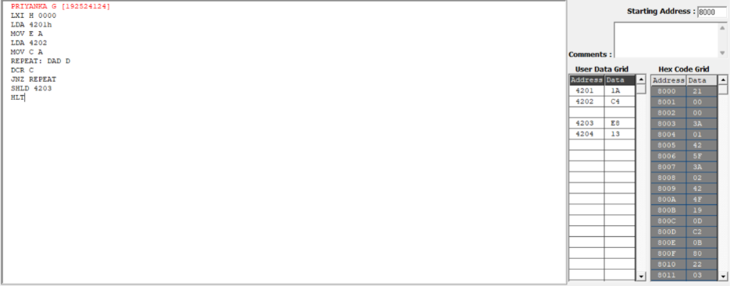

Memory | Data
4201 | 1A
4202 | C4
4203 | E8
4204 | 13

PROGRAM [Division]
LDA 4201h MOV E A LDA 4200h MOV B A MOV A E MVI C 00h
AGAIN: CMP B JC STORE SUB B
INR C
JMP AGAIN STORE: STA 4203h MOV A C
STA 4202h HLT

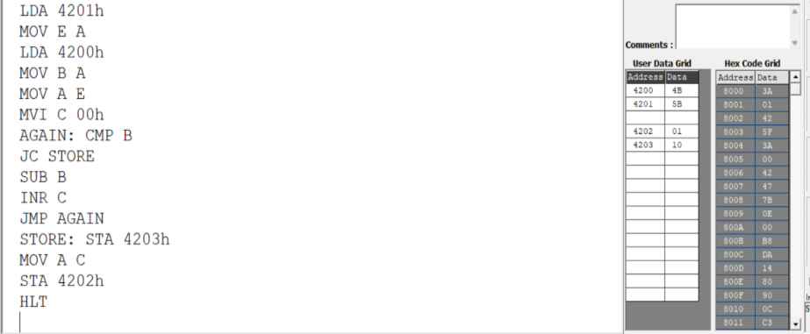
OUTPUT

Memory | Data
4200 | 4A
4201 | 5B
4202 | 01
4203 | 10

  - Analysis of 16-bit Multiplication and Division:

PROGRAM [Multiplication]
LXI H 4520
MVI M 00 INX H MVI M 00 INX H MVI M 00 INX H MVI M 00
LHLD 4500 XCHG LHLD 4502 MOV B H MOV C L
LOOP: MOV A B
ORA C JZ DONE
LHLD 4520 DAD D SHLD 4520 JNC SKIP LHLD 4522 INX H SHLD 4522
SKIP: DCX B JMP LOOP DONE: HLT

OUTPUT
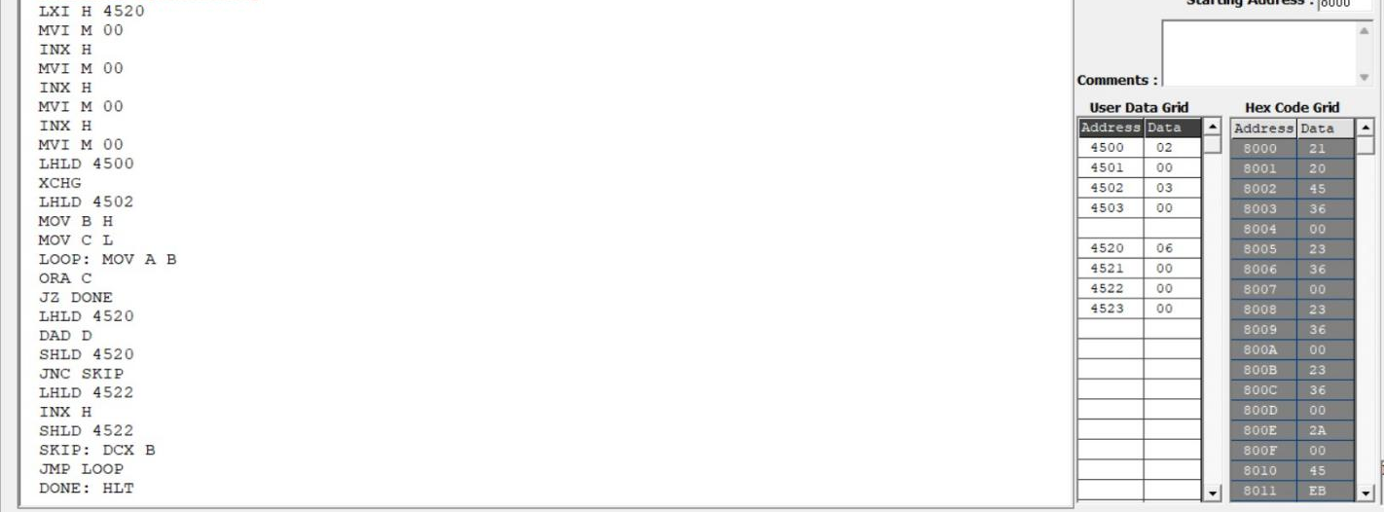

Memory | Data
4500 | 02
4501 | 00
4502 | 03
4503 | 00
4520 | 06
4521 | 00
4522 | 00
4523 | 00

PROGRAM [Division]

LXI H 0000
SHLD 4514
LHLD 4510 XCHG DIVLOOP: LHLD 4512 MOV A E SUB L MOV E A MOV A D SBB H MOV D A JC DONE XCHG SHLD 4510 XCHG
LDA 4514
INR A STA 4514
JNZ DIVLOOP
LDA 4515 INR A
STA 4515
JMP DIVLOOP DONE:
XCHG SHLD 4516 HLT

OUTPUT
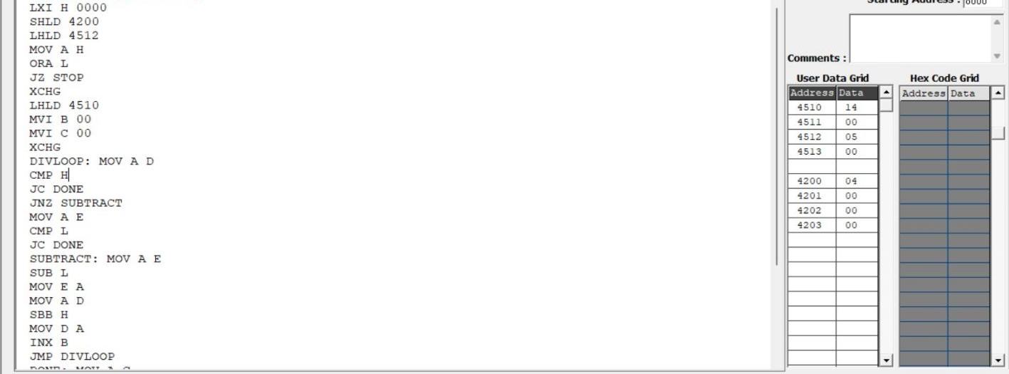

Memory | Data
4510 | 14
4511 | 00
4512 | 05
4513 | 00
4200 | 04
4201 | 00
4202 | 00
4203 | 00

Result:
Thus, 8-bit and 16-bit addition, subtraction, multiplication, and division programs were executed successfully using the 8085 microprocessors, and the results were verified by examining the specified memory locations and flag conditions.

DATE: 15/10/2026

EXPERIMENT 02: LOGICAL, BIT-MANIPULATION AND SHIFT OPERATIONS USING 8-BIT AND 16-BIT DATA

Objective:
- To analyze, develop and verify logical AND, OR and XOR operations.
- To analyze, develop and verify one's and two's complement operations on 8-bit and 16-bit data.
- To analyze, develop and verify bit setting, clearing, toggling, rotate and shift operations.
- To verify the output results and carry flag using the 8085 simulator.

Components Required:
8085 Simulator

Procedure:
- Switch ON the 8085-microprocessor trainer kit.
- Enter the program opcodes at the specified starting memory address using the memory examine/substitute command.
- Store the required input data in the specified memory locations.
- Execute Program A from 4100H and Program B from 4200H using the GO/EXEC command.
- Examine the memory locations assigned for the output results and flag byte.
- Record the output values and verify them against the expected hexadecimal results.
- Repeat the procedure for both programs and record the observations.

  - Analysis of Logical Operations

PROGRAM [AND,OR,XOR in 8-bit ]
LXI H, 4500H MOV A, M INX H
MOV B, M ANA B PUSH PSW STA 4502H POP H MOV A, L STA 4509H LDA 4500H ORA B
STA 4503H LDA 4500H XRA B
STA 4504H HLT

OUTPUT
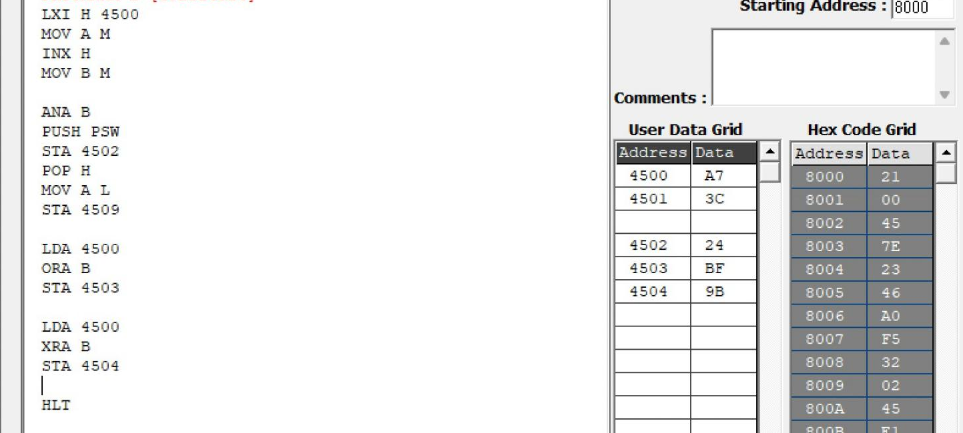

Memory | Data
4500H | A7H

4501H | 3CH
4502H | 24H
4503H | BFH
4504H | 9BH

PROGRAM [AND,OR,XOR in 16-bit ]
LDA 4500 MOV B A LDA 4502 ANA B STA 4504
LDA 4501 MOV B A LDA 4503 ANA B STA 4505
LDA 4500 MOV B A LDA 4502H ORA B STA 4506
LDA 4501
MOV B A LDA 4503 ORA B STA 4507
LDA 4500 MOV B A LDA 4502 XRA B STA 4508
LDA 4501 MOV B A LDA 4503 XRA B STA 4509 HLT

OUTPUT
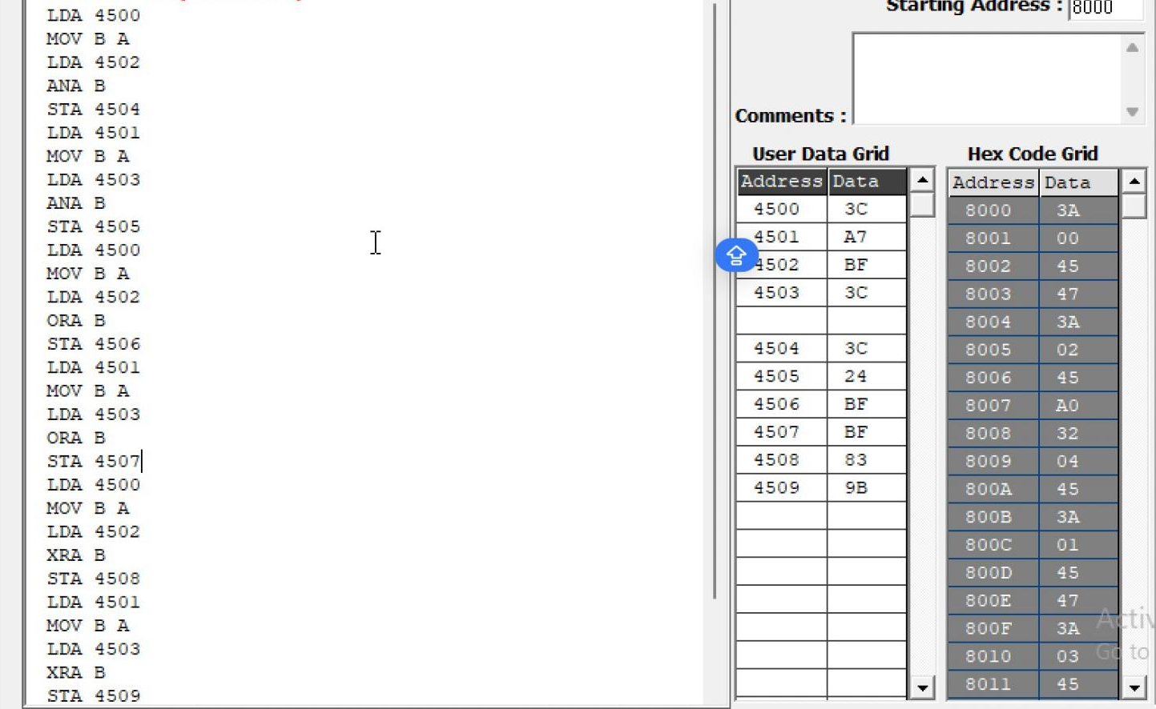

Memory | Data
4500 | 3CH
4501 | A7H
4502 | BFH
4503 | 3CH
4504 | 3CH
4505 | 24H
4506 | FFH
4507 | BFH
4508 | 83H
4509 | 9BH

  - Analysis of One's and Two's Complement

PROGRAM [16-bit]
LDA 4500H ANI 0FH STA 4505H LDA 4500H ANI F0H STA 4506H LDA 4500H CMA
STA 4507H INR A
STA 4508H
LHLD 450AH MOV A, L CMA
MOV L, A
MOV A, H CMA MOV H, A
SHLD 450CH INX H
SHLD 450EH HLT

OUTPUT
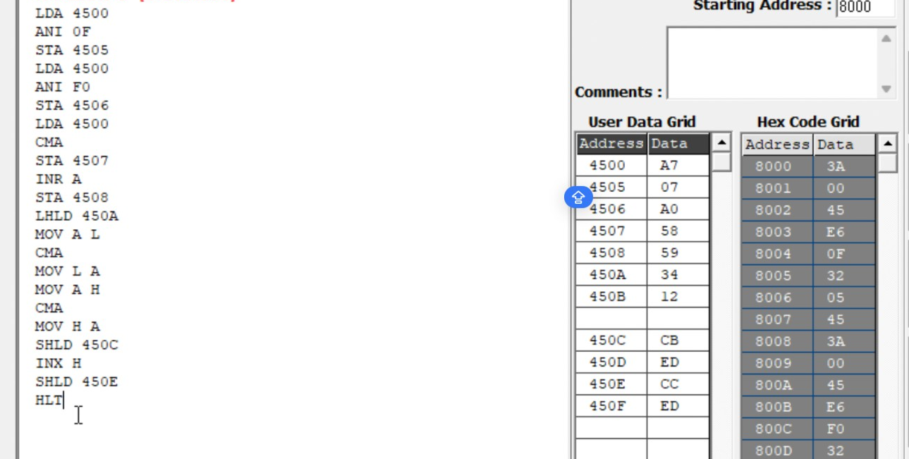
Memory | Data
4500 | A7
4505 | 07
4506 | A0
4507 | 58
4508 | 59
450A | 34
450B | 12
450C | CB
450D | ED
450E | CC
450F | ED

  - Analysis of Bit Setting, Clearing, Rotate

PROGRAM [Bit Manipulation]
LDA 4510H ORI 81H STA 4511H LDA 4510H ANI F5H STA 4512H LDA 4510H XRI 0FH STA 4513H MVI C, 00H LDA 4510H ANI 40H
JZ NEXT INR C
NEXT: MOV A, C
STA 4514H LDA 4510H RLC
STA 4515H LDA 4510H RRC
STA 4516H LDA 4510H ORA A
RAL
STA 4517H LDA 4510H ORA A
RAR
STA 4518H LDA 4510H MOV B, A RAL
MOV A, B RAR
STA 4519H LDA 4510H MVI B, 08H MVI C, 00H CNT: RLC
JNC SKIP INR C
SKIP: DCR B JNZ CNT MOV A, C STA 451AH HLT

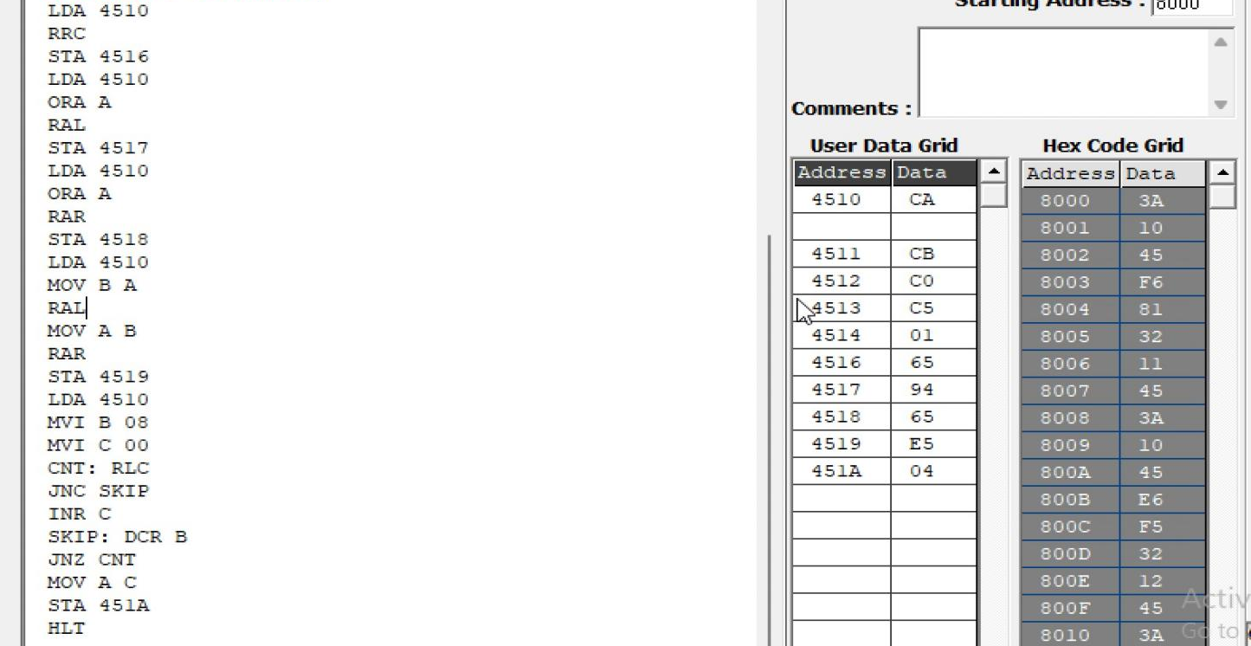
OUTPUT

Memory | Data
4510H | CAH
4511H | CBH
4512H | C0H
4513H | C5H
4514H | 01H
4515H | 95H
4516H | 65H
4517H | 94H
4518H | 65H
4519H | E5H
451AH | 04H

  - Analysis of Shift Operations

PROGRAM [16-bit Shift Left]
LHLD 4520H DAD H
SHLD 4522H HLT

OUTPUT
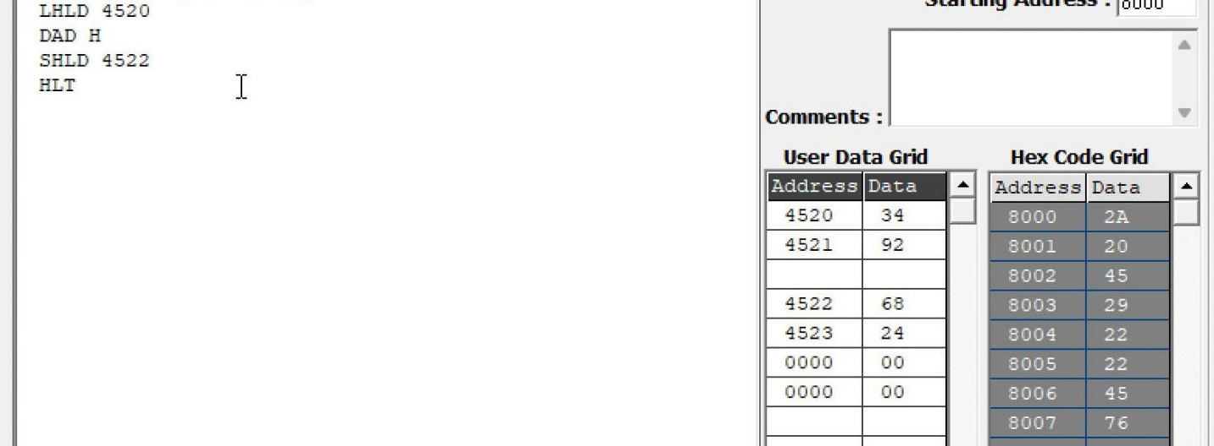

Memory | Data
4520H | 34H
4521H | 92H
4522H | 68H
4523H | 24H

Result:
Thus, the logical, bit-manipulation, complement, rotate and shift operations were performed using the 8085 simulator. The output values were examined in memory and verified against the expected hexadecimal results.

EXPERIMENT 03: MULTI-BYTE DATA AND ARRAY OPERATIONS USING 8086 INDIRECT ADDRESSING

Objective
To add two numbers using register-indirect and based addressing.
To find the sum of N 16-bit numbers stored in a word array.
To add two 64-bit numbers byte by byte with carry propagation using a loop.

Components Required
8086 Microprocessor Simulator, Computer system, Assembly Language Programming Software

Procedure
i. Switch ON the computer system and open the 8086 microprocessor simulator.
ii. Enter the 8086 assembly language program into the editor.
iii. Assemble the program and check for errors.
iv. Store the required input data in the specified memory locations.
v. Execute the program using the RUN command.
vi. Examine the registers and memory locations assigned for the results.
vii. Record the output values and verify them with the expected arithmetic results.
viii. Repeat the procedure for all three operations and record the observations.

1. To find the sum of N 16-bit numbers stored in a word array.
MOV SI, 2000H
MOV CX, 0005H
MOV AX, 0000H
NEXT: ADD AX, [SI]
ADD SI, 02H
LOOP NEXT
MOV [2010H], AX
HLT
OUTPUT:
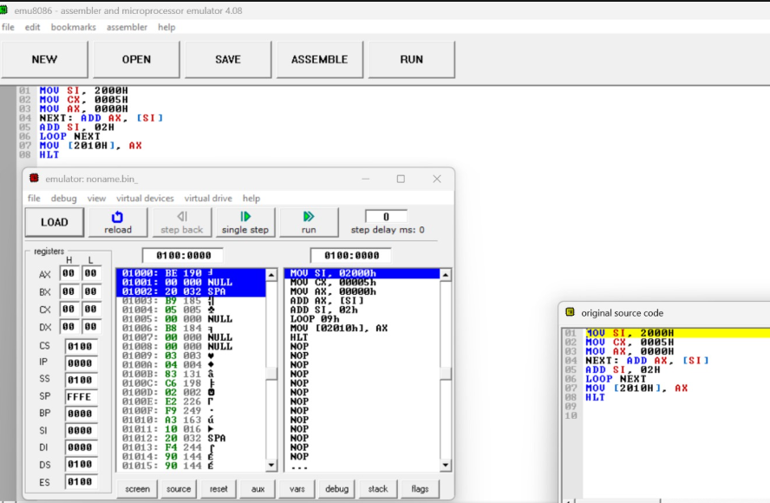
Address | Data
2000H | 0201H
2002H | 0304H
2004H | 0603H
2006H | 0200H
2008H | 0603H
2010H | 130BH

- To add two 64-bit numbers byte by byte with carry
MOV SI, 2000H
MOV DI, 2008H
MOV BX, 2010H
MOV CX, 0008H
CLC
NEXT: MOV AL, [SI]
ADC AL, [DI]
MOV [BX], AL
INC SI
INC DI
INC BX
LOOP NEXT
MOV AL, 00H
ADC AL, 00H
MOV [2018H], AL
HLT
OUTPUT:
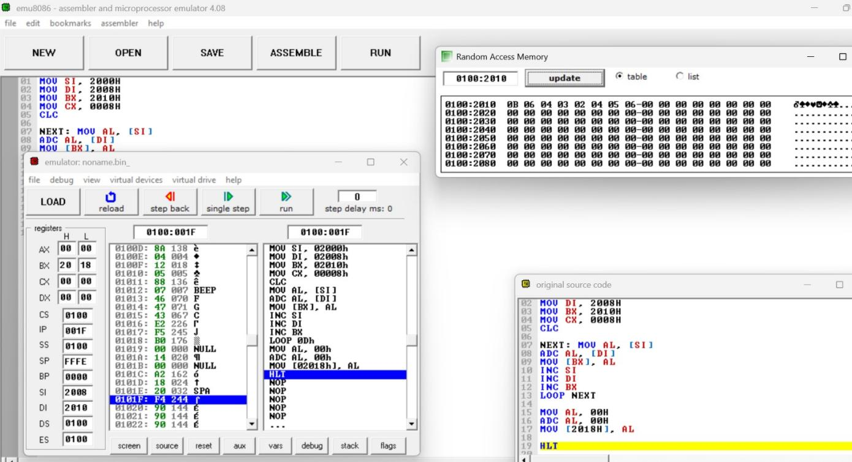
Address | Data
2010H | 23H
2011H | 56H
2012H | 89H
2013H | BCH
2014H | EFH
2015H | 22H
2016H | 56H
2017H | 79H
2018H | 01H
RESULT:
Thus, the 8086 assembly language programs for finding the sum of N 16-bit numbers and adding two 64-bit numbers with carry propagation were executed successfully, and the outputs were verified.

EXPERIMENT 04: STRING AND BLOCK DATA OPERATIONS USING 8086 MICROPROCESSOR

Block Transfer with REP MOVSB

CLD

MOV SI, 3000H

MOV DI, 3100H

MOV CX, 000BH

REP MOVSB

HLT

Output

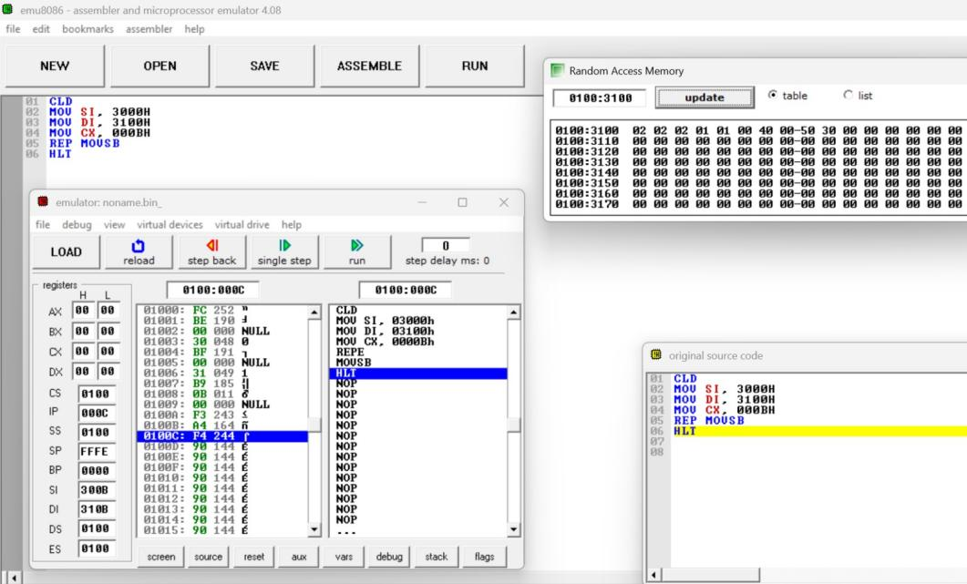

String Comparison with REPE CMPSB

CLD

MOV SI, 3200H

MOV DI, 3210H

MOV CX, 0003H

REPE CMPSB

JNE DIFF

MOV BYTE PTR [3220H], 00H

HLT

DIFF: MOV AX, 0003H

SUB AX, CX

MOV [3220H], AL

HLT

OUTPUT:

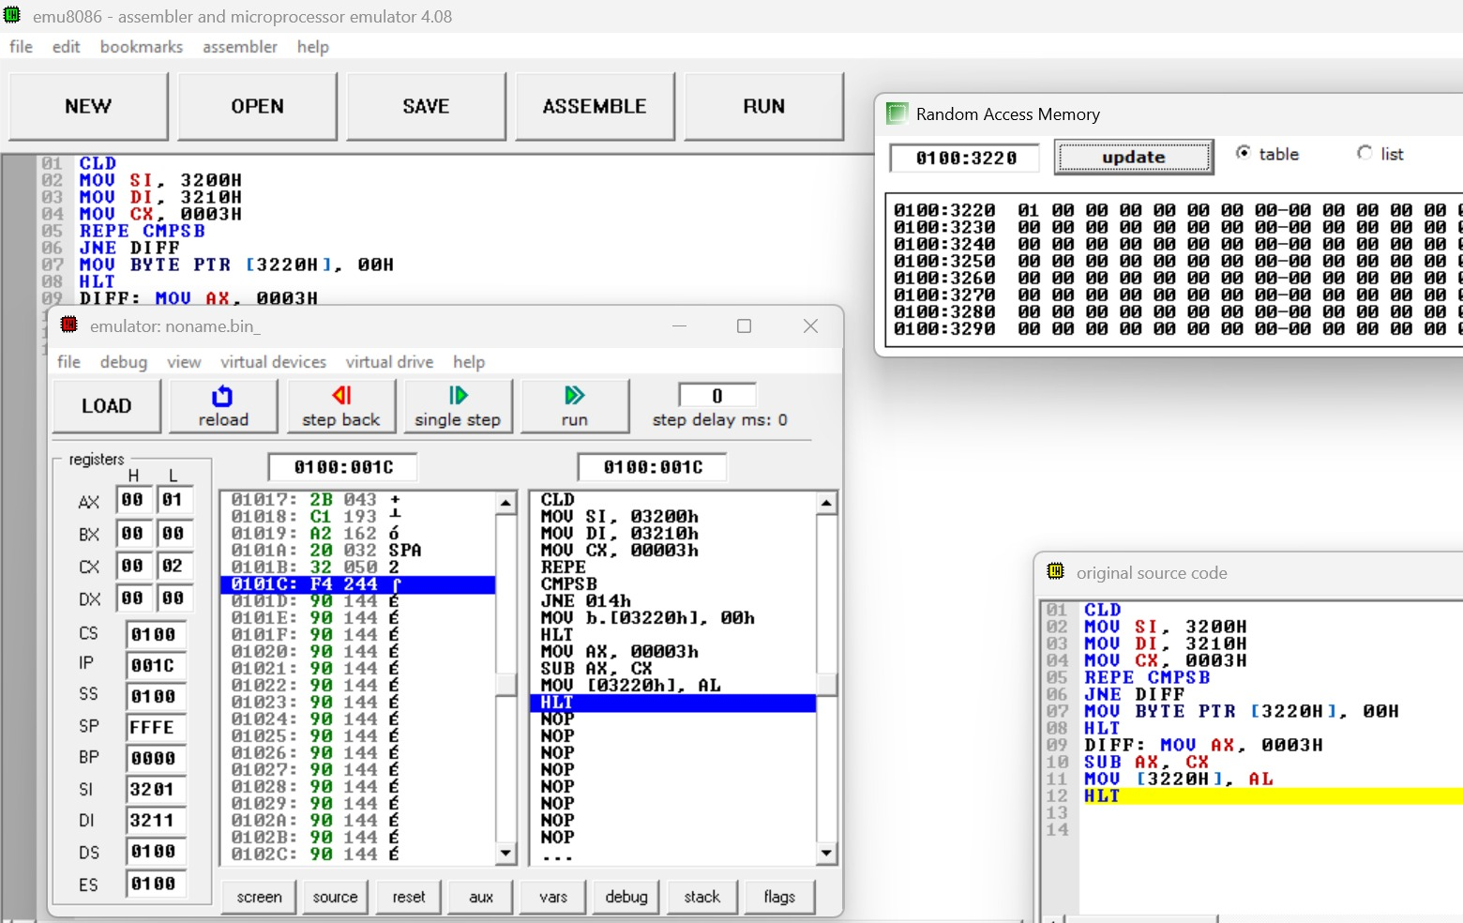

Character Search with REPNE SCASB

CLD

MOV DI,3300H

MOV CX,000CH

MOV AL,41H

MOV BL,00H

MOV DX,0000H

AGAIN: SCASB

REPNE

JNE DONE

INC BL

CMP DX,0000H

JNE SKIP

MOV DX,DI

SUB DX,3300H

SKIP: JCXZ DONE

JMP AGAIN

DONE: MOV [3310H],BL

MOV [3311H],DL

HLT



